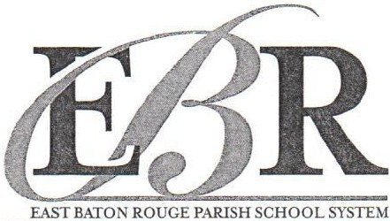

Twin Oaks Elementary School
819 Trammell Drive
Baton Rouge, LA 70815 Office (225) 275-6620, Fax (225) 275-2828

WARNING!!!

To the Parent/Guardian of: _,

At Twin Oaks Elementary School, we are working diligently to ensure that each child is successful and receives the best educational experience. One of the fundamental principles of that success is providing a safe and orderly environment conducive to learning, which also includes the school bus.

Your child was referred to the Discipline Office on ______________ for displaying inappropriate
behaviors on the bus. The school will take the necessary steps to re-teach our Bus expectations with the hopes that the students will understand and respect bus safety procedures.

In the meantime, let this notice serve as an official warning that if this behavior continues, a mandatory parent conference is necessary before the student can begin riding the bus again.
Your Partner in Education,
T. Junda, Principal

Consequences for Inappropriate Behavior

Students may be subject to the following consequences for minor offenses:

First Offense:
- A conference will be held with the student
- Parent/guardian will be notified
- Warning citation will be issued

Second Offense
1. Conference with student and parent
Third Offense
- Witten notification to parent/guardian
- Student will be denied bus transportation for 3-5 days

Fourth Offense
Permanent suspension for the school year from all bus transportation will be enforced after notifying parent/guardian.

Note: Major offenses will result in more severe punishment, such as suspension/expulsion from school. Any misbehavior on the bus, walking to or from the bus stop, or going to or returning from school may result in temporary or permanent loss of bus riding privileges. In this case, transportation to and from school becomes the responsibility of the parent/guardian.

A SACS/CASI ACCREDITED SCHOOL DISTRICT AN EQUAL OPPORTUNITY EMPLOYER

